DIGITAL MARKETING

Assignment 3- Create a social media poster using Canva

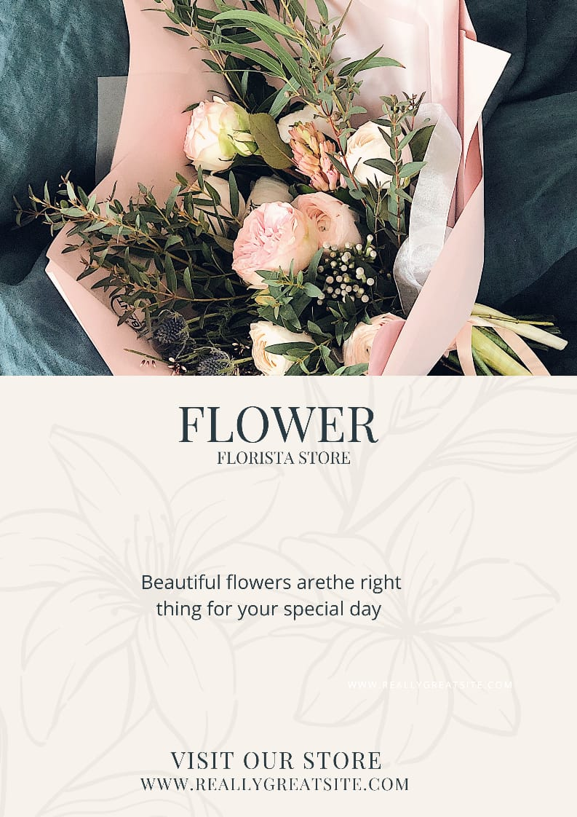

Figure: Social media poster on a flower shop